# Homework: CSS-Presentation

This document defines homework assignments from the [“Web Fundamentals (HTML & CSS)“ Course @ SoftUni](https://softuni.bg/courses/web-fundamentals/). Please submit as homework a single zip / 7z archive holding the source code of all below described problems.

## The Jaunty Text Field

Create a HTML page like the image below. **100% accuracy is required.** Use **external CSS file** for the styles. Note that you do not have buttons, but text fields.

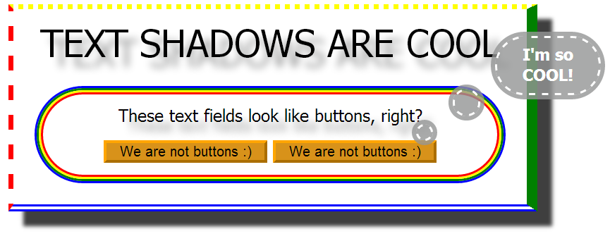

## SoftUni Hawaii Vacation

Create a HTML page like the image below. **100% accuracy is required.** Use **external CSS** file for the styles. You are given PNG files for the background, the figures and the TTF file of the font. Use radial gradient for the sky and the sun.

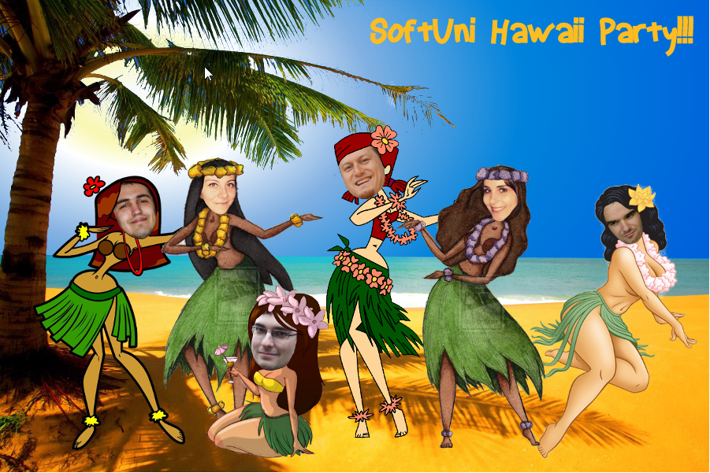

## Styling a HTML Form

Create a HTML page like the image below. **100% accuracy is required.** Use **external CSS** file for the styles. You are given PNG file for the background. Implement effects for active text field.

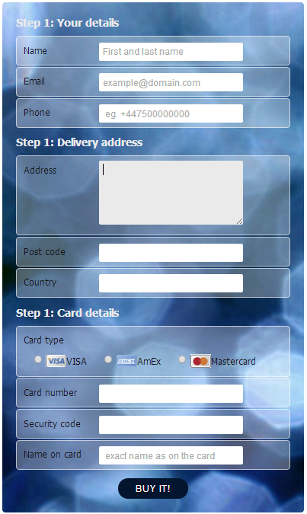

## * Nested <div> Elements

Create a HTML page like the image below. Use 60 nested <div> elements.Use **external CSS file** for the styles.

Hint: You may use Emmet (<http://emmet.io>) to simplify your coding effort.

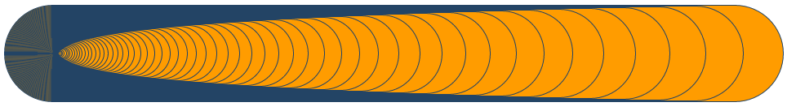

## * Programmer Calculator

Create a HTML page that looks like the Windows calculator in Programmer view (see the image below). **100% accuracy is required**. Use **external CSS** file for the styles. Implement hover effect for the buttons. The calculator should not have any functionality.

